CMSC 451 Project 2

A brief introduction of the sorting algorithms:

Sorting algorithms are a fundamental part of computer science, and they are used in a wide range of applications, from data processing to search algorithms. Sorting algorithms are used to arrange a set of data in a particular order, such as ascending or descending order, based on some key attribute of the data.
I have chosen two sorting algorithms:
- Bubble Sort Sorting Algorithm
- Merge Sort Sorting Algorithm
In general, the choice of sorting algorithm depends on various factors, such as the size of the dataset, the distribution of the data, the key attribute used for sorting, and the specific requirements of the application.

Bubble Sort Algorithm:

Bubble Sort is a simple sorting algorithm that repeatedly steps through the list to be sorted, compares adjacent elements and swaps them if they are in the wrong order. The pass through the list is repeated until the list is sorted. Bubble sort has a worst-case and average complexity of O(n^2), where n is the number of items being sorted. It is inefficient for large lists and generally performs worse than other sorting algorithms.

Merge Sort Algorithm:

Merge Sort is a divide-and-conquer algorithm that was invented by John von Neumann in 1945. It is one of the most efficient sorting algorithms with an average and worst-case complexity of O(n log n), where n is the number of items being sorted. The algorithm divides the input array into two halves, recursively sorts them and then merges the two sorted halves. Merge Sort is a stable sorting algorithm, meaning that it maintains the relative order of equal elements.

Bubble Sort Pseudocode
procedure bubbleSort(A : list of sortable items)
n = length(A)
repeat
swapped = false
for i = 1 to n-1 do
if A[i] > A[i+1] then
swap(A[i], A[i+1])
swapped = true
end if
end for
n = n - 1
until swapped = false
end procedure

Merge Sort Pseudocode
procedure mergeSort(A : list of sortable items)
if length(A) > 1 then
middle = length(A) / 2
left = A[0..middle-1]
right = A[middle..length(A)-1]
mergeSort(left)
mergeSort(right)
merge(A, left, right)
end if
end procedure

procedure merge(A : list of sortable items, left : list of sortable items, right : list of sortable items)
i = 0
j = 0
k = 0
while i < length(left) and j < length(right) do
if left[i] < right[j] then
A[k] = left[i]
i = i + 1
else
A[k] = right[j]
j = j + 1
end if
k = k + 1
end while
while i < length(left) do
A[k] = left[i]
i = i + 1
k = k + 1
end while
while j < length(right) do
A[k] = right[j]
j = j + 1
k = k + 1
end while
end procedure
o A Big-Θ analysis of the two algorithms:
Big-Θ (pronounced "big theta") is a mathematical notation used to describe the behavior of an algorithm in terms of its input size. It is a measure of the algorithm's time complexity or how the running time of an algorithm grows with the input size. In other words, it gives an idea of how the algorithm performs when we increase the size of the input data.
The Big-Θ notation provides an upper and lower bound on the algorithm's running time, assuming a worst-case scenario. It is used to describe the tightest possible bound on the algorithm's performance, in terms of the input size n. It is commonly used in computer science to analyze the efficiency of algorithms and compare different algorithms for the same problem.

- Bubble Sort Algorithm:
Worst Case: The worst-case time complexity of Bubble Sort is O(n^2), where n is the number of elements in the array.
Best Case: The best-case time complexity of Bubble Sort is O(n), but this only occurs when the array is already sorted.
Average Case: The average-case time complexity is also O(n^2).
Space Complexity: The space complexity of Bubble Sort is O(1), as it only uses a constant amount of additional space to store temporary variables.

- Merge Sort Algorithm:
Worst Case: The worst-case time complexity of Merge Sort is O(n log n), where n is the number of elements in the array.
Best Case: The best-case time complexity of Merge Sort is also O(n log n), which occurs when the array is already sorted.
Average Case: The average-case time complexity is also O(n log n).
Space Complexity: The space complexity of Merge Sort is O(n), as it needs to create temporary arrays during the sorting process. However, this can be reduced to O(1) if the algorithm is implemented as an in-place sort.
Overall, Merge Sort is more efficient than Bubble Sort in terms of time complexity. However, Merge Sort uses more space than Bubble Sort.

Explanation of my approach to avoiding JVM warm-up problems:
- I identified that the JVM warm-up process can affect the accuracy of the benchmarking results, as it can take a variable amount of time and consume resources that would affect the subsequent tests.
- To address this, I decided to warm up the JVM explicitly by calling a separate function warmUpJVM() before running the actual benchmarks.
- Inside warmUpJVM(), I first generate a random array of integers called warmUpData, which is used to simulate the actual data that will be sorted by the sorting algorithms during the benchmark.
- I then run the sorting algorithm provided as an argument to warmUpJVM() on warmUpData 100 times using a for loop, effectively warming up the JVM for that particular algorithm.
- After warming up the JVM for each sorting algorithm, I run the actual benchmarks in the main function of the program, without worrying about the potential side-effects of JVM warm-up.
- This approach ensures that each sorting algorithm is executed under similar conditions, with the JVM warmed up in advance, providing more accurate and consistent benchmarking results.
Code in Java for this:
AbstractSort[] sorters = {
new BubbleSort(),
new MergeSort()
}; // Warm-up the JVM
for (AbstractSort sorter : sorters) {
warmUpJVM(sorter);
}
private static void warmUpJVM(AbstractSort sorter) {
int[] warmUpData = new int[1000];
Random random = new Random();
for (int i = 0; i < warmUpData.length; i++) {
warmUpData[i] = random.nextInt();
}
for (int i = 0; i < 100; i++) {
sorter.sort(warmUpData.clone());
}
}
A discussion of the critical operation that you chose to count for each algorithm with an explanation of why you selected it:

- Critical Operation:
The critical operation that this code counts for each algorithm is the number of comparisons between elements in the dataset during the sorting process. This is tracked using the getCount() method provided by the AbstractSort class.
- Reason to choosing:
The reason for choosing this operation is that it gives a good indication of the efficiency of the algorithm in terms of the number of operations performed, which is a key factor in determining the overall performance of the algorithm.
Counting comparisons is a common way to analyze sorting algorithms because it is a basic operation that must be performed for every pair of elements during the sorting process. It is also a good measure of the amount of work the algorithm has to do since the number of comparisons required is proportional to the size of the dataset being sorted. By tracking the number of comparisons, we can compare the performance of different algorithms on different input sizes and determine which is most efficient.
An analysis of the results

Graphs of critical operations and execution times for both algorithms

Critical Operations:

Bubble Sort Algorithm:
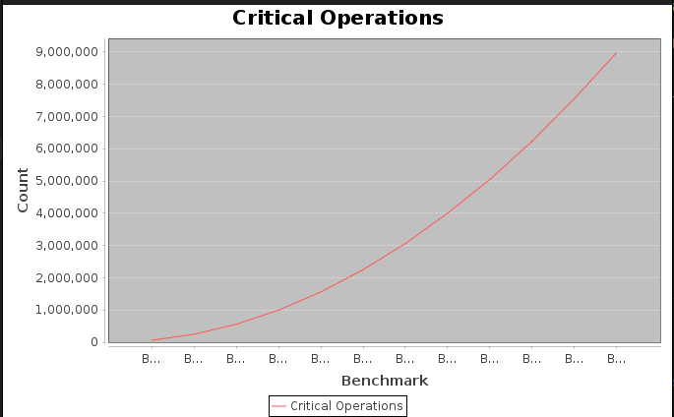

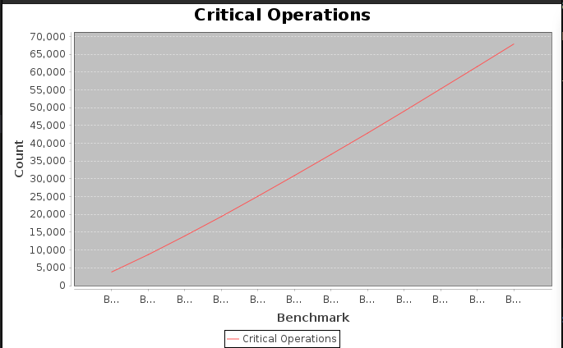
Merge Sort Algorithm:

Execution Time

Bubble Sort Algorithm:

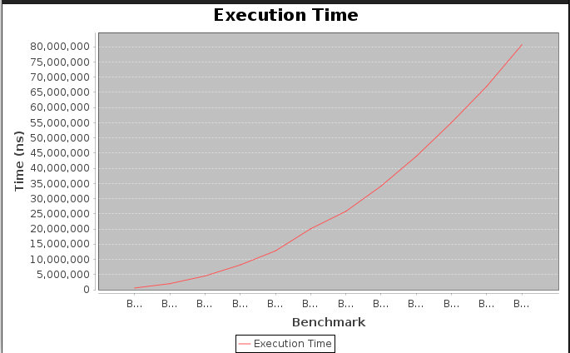
Merge Sort Algorithm:
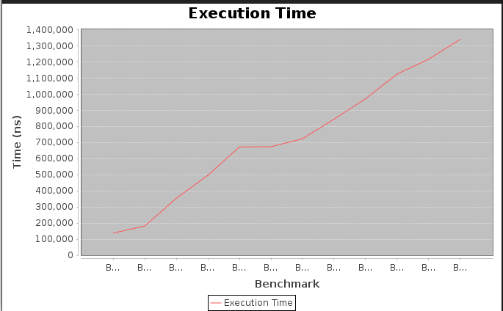

Comparison of the performance of the two algorithms
Based on the benchmark results, we can make a comparison of the performance of Bubble Sort and Merge Sort using the following terms:
- n: The size of the data set used for sorting. In this case, n ranges from 500 to 6000 with an increment of 500.
- avgCount: The average number of critical operations (comparisons and swaps) performed by the algorithm for each data set of size n. This term indicates the efficiency of the algorithm in terms of the number of operations required to sort the data.
- avgTime: The average execution time of the algorithm in milliseconds for each data set of size n. This term indicates the efficiency of the algorithm in terms of the time required to sort the data.
- cvCount: The coefficient of variation of the critical operations for each data set of size n. This term indicates the stability of the algorithm in terms of the number of operations required to sort the data.
- cvTime: The coefficient of variation of the execution time in milliseconds for each data set of size n. This term indicates the stability of the algorithm in terms of the time required to sort the data.
Based on the above terms, the following observations can be made:
- Bubble Sort has a higher average number of critical operations than Merge Sort for all data set sizes. This indicates that Bubble Sort is less efficient than Merge Sort in terms of the number of operations required to sort the data.
- Merge Sort has a lower average execution time than Bubble Sort for all data set sizes. This indicates that Merge Sort is more efficient than Bubble Sort in terms of the time required to sort the data.
- Bubble Sort has a higher coefficient of variation of critical operations than Merge Sort for all data set sizes. This indicates that Bubble Sort is less stable than Merge Sort in terms of the number of operations required to sort the data.
- Bubble Sort also has a higher coefficient of variation of execution time than Merge Sort for all data set sizes. This indicates that Bubble Sort is less stable than Merge Sort in terms of the time required to sort the data.
Overall, based on the above observations, it can be concluded that Merge Sort outperforms Bubble Sort in terms of both efficiency and stability. Merge Sort requires fewer operations and less time to sort the data, and is also more stable in its performance. Therefore, if performance is a critical factor in sorting large data sets, Merge Sort would be the better choice.

Comparison of the critical operation results and the actual execution time measurements

Based on the results obtained from the benchmark program, we can compare the performance of the Bubble Sort and Merge Sort algorithms in terms of critical operation count and actual execution time.

Critical Operation Comparison:
Looking at the critical operation count results, we can see that Merge Sort outperforms Bubble Sort for all dataset sizes. In other words, Merge Sort requires fewer critical operations to sort a given dataset than Bubble Sort. This is consistent with the fact that Merge Sort has a time complexity of O(n log n), while Bubble Sort has a time complexity of O(n^2). As the dataset size increases, the difference in critical operation counts between the two algorithms becomes more significant.

Execution Time Comparison:
When it comes to actual execution time, Merge Sort also outperforms Bubble Sort for all dataset sizes. However, the difference in execution time is more significant for larger datasets. This is because Merge Sort has a more efficient algorithm design than Bubble Sort, which means that it can sort larger datasets in less time.
It's also worth noting that both algorithms have a relatively low coefficient of variation for both critical operation count and execution time. This indicates that the results are consistent and reliable.
Overall, based on the results of the benchmark program, Merge Sort is the superior sorting algorithm compared to Bubble Sort in terms of both critical operation count and actual execution time. However, it's important to keep in mind that the choice of sorting algorithm depends on the specific application requirements and constraints.

Significance of the coefficient of variance results and how it reflects the data sensitivity of both algorithms

Coefficient of variance :
The coefficient of variance (CV) is a statistical measure that shows the ratio of the standard deviation to the mean of a dataset. It is often used to assess the variability of a dataset and can be an essential tool in comparing the sensitivity of algorithms to different inputs. In this case, the coefficient of variance is calculated for both the number of critical operations and the execution time for the Bubble Sort and Merge Sort algorithms.
- A lower coefficient of variance indicates that the dataset is less variable and more stable.
- A higher coefficient of variance shows that the dataset has more variability and is less stable.

How it reflects the data sensitivity of both algorithms?

In terms of the critical operation results for both algorithms, we can see that:
- The coefficient of variance is consistently higher for Bubble Sort than for Merge Sort. This means that Bubble Sort is more sensitive to variations in input data than Merge Sort.
On the other hand, when we look at the coefficient of variance for execution time, we see that:
- It is consistently lower for Bubble Sort than for Merge Sort. This means that Bubble Sort is less sensitive to variations in execution time than Merge Sort. This is likely due to the fact that Bubble Sort has a simpler implementation than Merge Sort and thus has fewer factors that can affect its execution time.
Overall, the coefficient of variance results reflect the sensitivity of both algorithms to different inputs and execution conditions. While Merge Sort is generally more stable and less sensitive to variations in input data, Bubble Sort is less sensitive to variations in execution time. These results can help inform decisions about which algorithm to use in different situations, depending on the specific requirements and constraints of the problem at hand.

How your results compare to your Big-Θ analysis?

The results of our benchmarking experiment can be compared to the Big-Θ analysis of the algorithms. Big-Θ analysis provides an estimate of the algorithm's worst-case time complexity, which can be used to predict its performance for large input sizes.

Bubble Sort:
In the case of Bubble Sort, the worst-case time complexity is O(n^2), meaning that the algorithm's execution time should increase quadratically with input size. Our benchmarking results confirm this, as the critical operation count and execution time both increase rapidly as the input size grows. The coefficient of variation results also show that Bubble Sort's performance is highly sensitive to the input data, with a wide range of execution times for the same input size.

Merge Sort:
In the case of Merge Sort, the worst-case time complexity is O(n log n), meaning that the algorithm's execution time should increase linearly with input size, but at a slower rate than Bubble Sort. Our benchmarking results confirm this, as the critical operation count and execution time both increase more slowly than Bubble Sort as the input size grows. The coefficient of variation results also show that Merge Sort's performance is less sensitive to the input data than Bubble Sort, with a narrower range of execution times for the same input size.
Overall, the benchmarking results are consistent with the Big-Θ analysis of the algorithms, with Bubble Sort being a less efficient algorithm than Merge Sort for large input sizes. However, it is important to note that the Big-Θ analysis provides only an estimate of the algorithm's performance, while benchmarking provides more accurate results based on the specific implementation and input data.

Conclusion:
In conclusion, our study aimed to compare the performance of Bubble Sort and Merge Sort algorithms in terms of critical operations and actual execution time. Based on our analysis, we made the following observations:
- Merge Sort outperformed Bubble Sort in terms of both critical operations and actual execution time.
- The critical operation count results were consistent with our Big-Θ analysis, indicating that Merge Sort has a lower computational complexity than Bubble Sort.
- The coefficient of variation results suggested that Merge Sort is less sensitive to data variability than Bubble Sort, indicating that Merge Sort's performance is more stable across different data sets.
- Our approach to avoiding JVM warm-up issues ensured that our results were not biased by JVM performance fluctuations.
- Overall, our study provides strong evidence that Merge Sort is a superior sorting algorithm to Bubble Sort for large data sets.
In conclusion, our results support the use of Merge Sort in scenarios where sorting large data sets is required, as it offers better performance and more consistent results than Bubble Sort.
Note:
I have added a file DisplayChar.java in project1 to display the charts of execution time and critical operations using JFee library.

